Problem
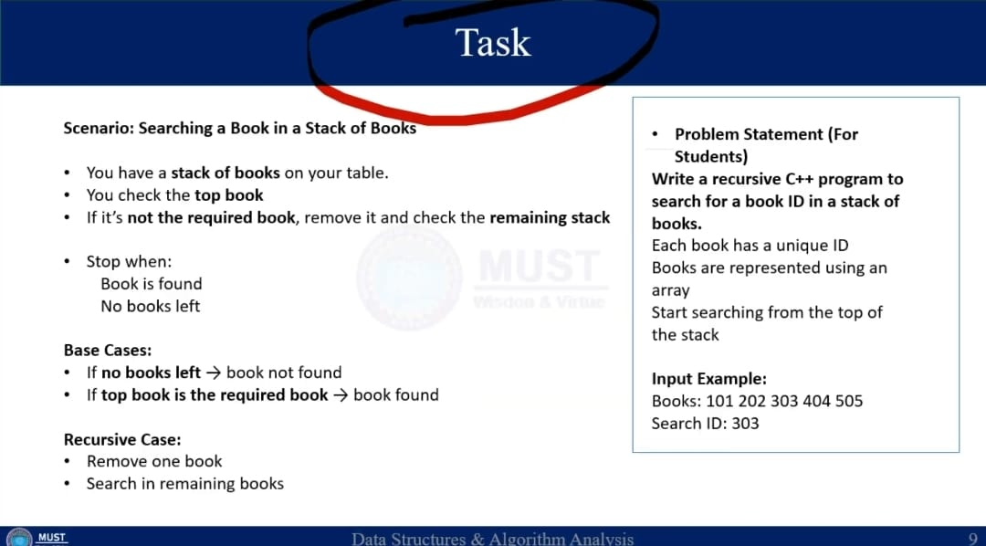
CODE:
#include <iostream>
using namespace std;
// Recursive function to search book ID in stack
bool searchBook
(int books[], int top, int searchID)
{
// Base Case 1: No books left
if (top < 0)
{
return false;
}

// Base Case 2: Top book is the required book
if (books[top] == searchID)
{
return true;
}

// Recursive Case: Remove top book and search remaining stack
return searchBook(books, top - 1, searchID);
}

int main()
{
int books[] = {101,102, 103, 104, 105};
int n = sizeof(books) / sizeof(books[0]);
int searchID;

cout << "Enter Book ID to search: ";
cin >> searchID;
if (searchBook)
(books, n - 1, searchID)
{
cout << "Book found in the stack." << endl;
}
Else
{
cout << "Book not found in the stack." << endl;
}
return 0;
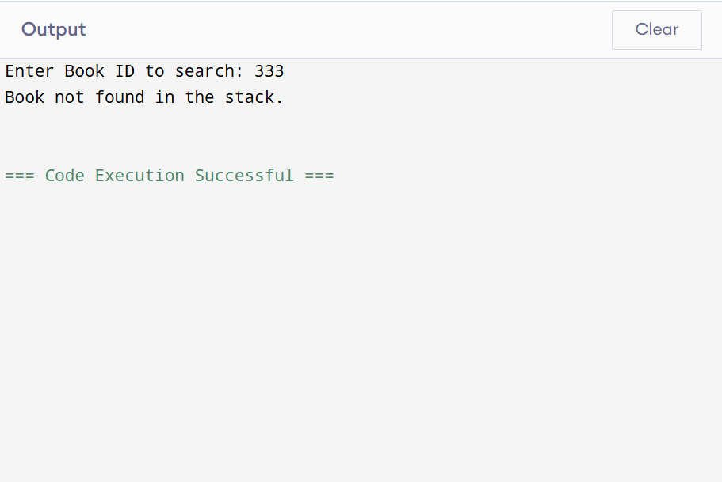
OUTPUT: (1)
when
book isn’t in stack.

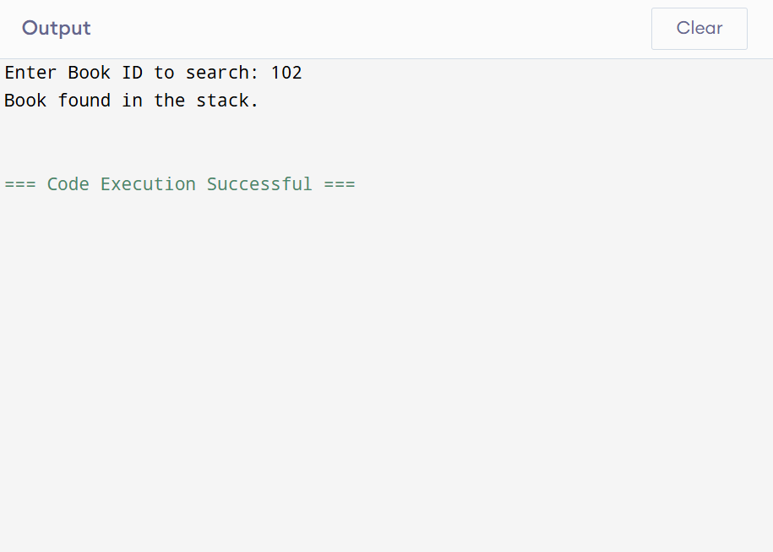
(2).
When book is in stack.

